I Grieved the Lord & Christmas
November 24, 20 17
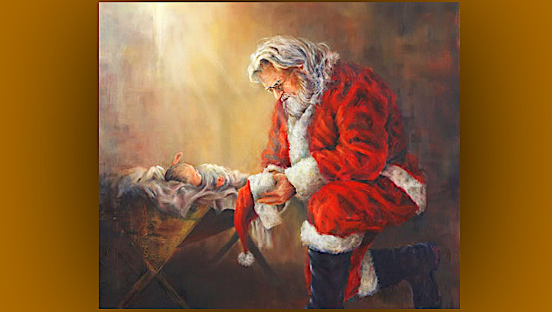
Father, please give us tender hearts for Your Son, that we never stand Him up for frivolous and empty pleasures, but rather honor that time set aside for Him without compromising. Amen

Well, I got lax and lazy today and allowed my mind to wander into a couple of YouTubes—one about Cern and one about Nibiru, then another stop, Ukraine’s Got Talent. I don’t know about you, but when I think about the obstacles some of those contestants overcome to make it to that stage, I am really inspired to be more dedicated to the Lord.

Nevertheless, it was NOT the proper use of time and I allowed myself to get into a deaf lull… and not heed the voice of the Lord.

When I get into those deaf places, I don't hear anything. Really, most of the time my ears are open to the Lord. When I get in those places, I kind of go into my own world.

So, I came to the Lord after communion, and I said, 'How can I say I am sorry when I feel so dry. So terribly dry?'

Jesus began, “Even when you are dry, still I am with you. I love you and hold you by your right hand—and sometime, beyond all your expectations, I will take you into Glory.

"But recently I've told you not to be so hard on yourself and now I must tell you to be a little harder on yourself. Need I go into explanations?"

No, Lord, I get it.

He continued, "At the first sign of distraction and departing from what you know to be My perfect will, stop yourself, Clare. Do not allow yourself to play deaf and do it anyway, please. You have wasted time tonight and you’ve lost graces. It is so important to Us that you keep your focus on Our Will, not the things that catch your fancy."

Lord, I feel like what you once told Ezekiel and I—You can bend a bow until it breaks. I feel like I needed some inspiration or distraction. Something a little different.

He continued, "Yes, I know, Beloved. But I would rather pick your distractions than have you led away blindly by the enemy, where he can plant things in your head and direct you off course. Do you understand that?"

Yes, and I feel convicted. I was tired and curious and gave into it, even though I knew better. And now I feel so dry. I don’t feel the repentance I should for having done that.

Jesus continued, "The kind of repentance you are wanting to feel is a gift for true contrition. True contrition means that you are sorry for hurting Me. You haven’t reached that point yet.

"What’s lacking is your understanding of how I wait for you and how you put Me off for a curiosity... and just how disrespectful that is. The very moment you know I am waiting for you, drop what you are doing and come to Me, Clare. Don’t put it off. I will not wait forever…

"Like the Beloved in the Song of Songs, will you to say to Me, 'I have washed my feet, shall I dirty them again to open the door for you?' She, that night," Jesus continued, "was not worthy of My visitation but rather merited a beating for her presumption.”

And that's in the Song of Songs, the fifth chapter.

The Beloved said, “I slept but my heart was awake. Listen! My beloved is knocking: 'Open to me, my sister, my darling, my dove, my flawless one. My head is drenched with dew, my hair with the dampness of the night.' I have taken off my robe—must I put it on again? I have washed my feet— must I soil them again?”

Then it goes on:

"My beloved thrust his hand through the latch-opening; my heart began to pound for him. I arose to open for my beloved, and my hands dripped with myrrh, my fingers with flowing myrrh, on the handles of the bolt. I opened for my beloved, but my beloved had left; he was gone.

“My heart sank at his departure. I looked for him but did not find him. I called him but he did not answer.

"The watchmen found me as they made their rounds in the city. They beat me, they bruised me, they took away my cloak, those watchmen of the walls!

"Daughters of Jerusalem, I charge you—if you find my beloved, what will you tell him? Tell him I am faint with love." Song of Songs 5:1-8

That's a beautiful description of a visitation from the Lord.

Jesus continued, "That truly is the state of the church. Many look at what they’ve done. so that they can rest and find their ease, but forget just how holy I am and how much respect they should have for our prayer times together. Familiarity can cultivate contempt. And for such as these I will not come to the door again.

"My Bride. Can you be more attentive, Clare? Less curious, less sluggish? Truly these are long-standing shortcomings of yours, My Love, and I will celebrate the day you lay them down never to return to them again."

Lord, in my zeal to please You and get underway with the portrait and songs, truly I have not spent the time we both need together. As a result, I’ve become luke-warm and need to return to my First Love.

He continued, "This is a universal problem with most of My ministers. They become so excited with the beauty of the work and a feeling of being used, they slowly cut their time with Me shorter and shorter to accommodate their need to produce. This need not be with you, My Clare. You know better and I’m happy that you are nipping it in the bud."

Jesus, without the Living Waters of Your heart, I die inside… Then my works become dead works. Thank You, eternally, for your patience with me.

My face had been downcast, during this entire conversation, but He lifted my chin until our eyes met. They were so vulnerable, I began to feel deep remorse, and tears welled up.

I realized, 'He waited, but I didn’t come until late. Really late. He didn’t give me what I deserved, rather He tenderly admonished me. How could I do this to Him?'

You see, Heartdwellers, when I tell you He chose me because I was so unsuited and so inferior for this job, you think I’m just trying to be humble. But I’m not. I see this clearly; I am not worthy.

So, if you feel unworthy, do not be afraid, do not stand far off from Him. Rather, seek Him until you find Him, break your heart like a vial of costly Myrrh and pour it over His aching Heart. Comfort Him, Heartdwellers, comfort Him in the depths of His heart for all of those who will ignore the even the celebration of His birth.

Jesus continued, “Now I can forgive you, Clare. You have felt the pain in your own heart and I forgive you.”

Thank you, Jesus.

And that was the end of that part of the message. And I want to say here, please don't tell me this is a pagan holiday. He has already spoken about Christmas before; there are true graces to be had during this season.

There are devout souls all over the world who fast and pray for 30 days to prepare their hearts for baby Jesus to come. They celebrate His birth with their own traditions, but more importantly, they worship Him and thank the Father for this sublime gift of His Son.

Western Europe and the United States are so different from them. This is retailer’s dream come true, where they make huge profits from eager shoppers every year at Christmas-time.

And I want to say something hear about the timing of Christmas. I think we all know that that's not exactly when the Lord was born. But that's the way the early church set it.

And I want to say: has it ever occurred to any of us, that the church may have deliberately set this celebration to offset covens that are committing the worst sins and sacrificing infants? Is it possible that perhaps this date was set because of the prayers and devotion of the people before contemporary times?

For instance. I have been to monasteries. If you saw the schedule of the interceding nuns in convents, you would see worship and prayer, several times a day—and night. Not malls and shopping and feasting. But all in all, they are praying for the salvation of souls and living a dedicated life of prayer—while the secular world is partying and Satan is being worshipped.

So, let’s be careful not to condemn things at face value—just because others do that. Rather, take time and go deep. Find out for yourself what spiritual battles are going on in Heaven, and who around the world is interceding for more souls to be saved. And how are the seasons tied into that.

Many talk about the pagan holidays, and how the church has holidays on the pagan holidays. Well, I understand what they're saying, and it is true. But I think we have to dig a little deeper to understand the motives for that. They're not necessarily to be condemned for doing that. There are other reasons to be considered. But most of us just blindly follow whatever everyone says and make a judgment, without really going deeper to find out whether or not it's true.

Anyway... Lord, forgive me for digressing.

Jesus began again, "My Clare, when I see a little child holding a baby Jesus doll and putting Him in the manger so tenderly, My Heart wells up with tears. They are learning the deep significance of this time of giving. They are seeing and touching this moment in time when My Father made the supreme sacrifice. They are remembering the fresh scent of spruce boughs, the cookies and colored lights and presents. Everything is geared to sublime celebration, for the Gift of all gifts has just been given them.

"I see their future. I see the secularization. I see the greed. I see all these things, too. But there will come a time when they grow up, and remember back as children. They'll realize the real true wonder of Christmas was My Birth and these memories will be very dear to them.

"Thank you, mothers, who are teaching your children the true meaning of Christmas. You make up for the deep wounds of My Heart because Satan has hijacked and perverted this celebration.

"And for those of you who are witnessing to My birth in the third world by your generosity, you are sowing seeds that will bring forth generations of conversions."

